



W1662, the new cylinder bed interlock stitch machine
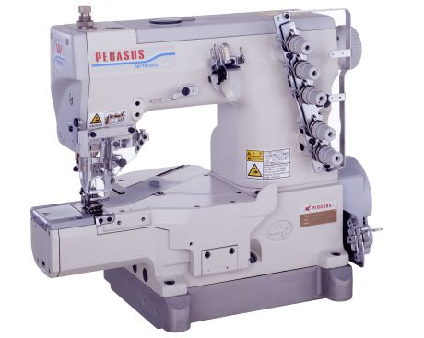

This new developed economical - high - speed cylinder bed machine is capable of a speed of up to 6000 rpm and ensures high productivity. W1662 - series offers basically almost the same features like W600 - series with additional and outstanding new technical points:

- A tight seam and soft seam are both easily achievable with the same machine by changing only the position of the “MTC” cam installation. “MTC” is Multi Thread Control.

- An additional adjustment to the sewing condition is possible.

- Improved ease of operation & maintenance
  - upper metal hand wheel
  - improved oil seals
  - independent adjustable stitch length and differential movement

  - colour marked thread guides for easy and simple threading
  - tilt adjustment of presser foot sole

We will explain in more detail:
NEW
    - A tight seam and a soft seam are achieved by one machine, by only changing the cam installation direction (upper and lower) and the appearance and elasticity of the stitch changes.

Tight stitch

W1662-○○○x□□□ □S – type.
Standard factory set up position
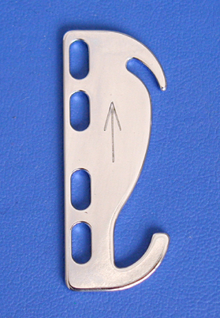
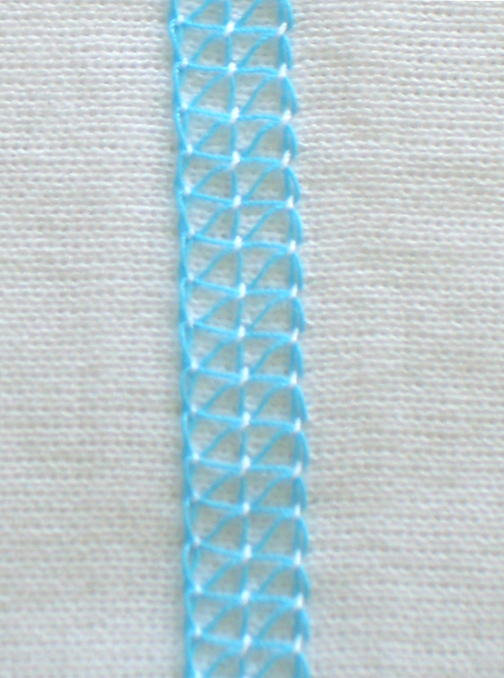
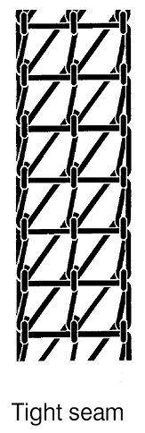

Tight stitch
>>> Mainly the thread tightening is applied when the needle is in the top position

Soft Stitch

W1662-○○○x□□□ □T – type, standard factory set up position
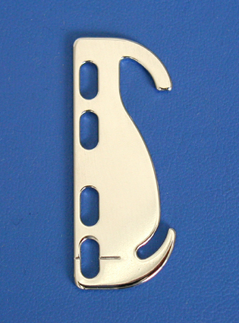
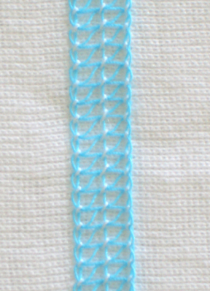
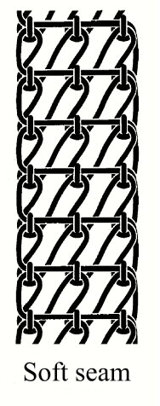

Soft stitch
>>>Mainly the thread tightening is applied when the needle is in the low position

    - The adjustment to the sewing condition is possible.

It is possible to correspond to a wide sewing condition by adopting the needle thread spring.

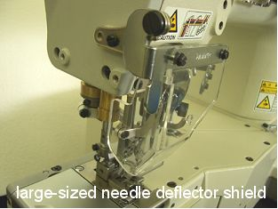
When it is necessary to make the needle thread loop small as required by cotton thread etc., it is possible to adjust easily.
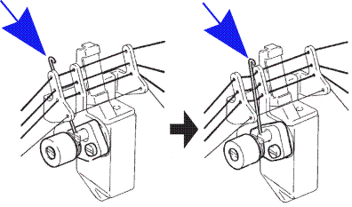
NEW

(1) (2)

- The needle thread spring is set not to work (factory set up).

(2) The slackness of the needle thread is absorbed by working needle thread take-up spring, and the needle thread loop will become small (cotton thread used).

CAUTIONS !!
In case the "needle thread pressure spring" is effective, except for "thread which makes bigger needle thread loop" such as cotton thread, skipp stitches can easy happen.

    - Improved performance and maintenance

1, Equipped with large-sized eye guard that also covers the left side near the needle and the parts around the needle, increasing safety. NEW
The newly introduced cam-type needle thread take-up eliminates several moving parts, such as the needle and spreader thread take-ups that were located on the front of the machine arm, increasing safety and decreasing noise and vibration.
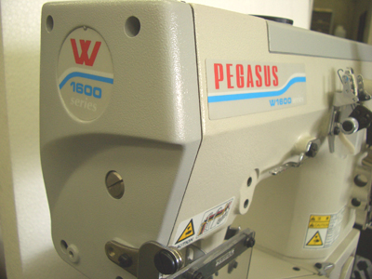
Thanks to these features, the operator feels less stress during sewing.

2, Feed dog mechanism
NEW
A push button is employed for adjusting the amount of movement of the main feed dog. On the W1600 Series, the amount of movement of main feed dog and diff. feed dog can not be adjusted synchronously, by using the push button. The amount of movement of the differential feed dog should be adjusted independently.

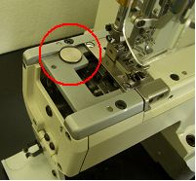

●Adjustment range for the main
feed dog: 1.0～4.4mm （W600：0.6～4.5mm）
●Adjustment range for the
differential feed dog ：0.8～6.0mm （W600：0.54～5.85mm）
This enables a higher differential ratio, if required.

2, Tilt adjustment and front to
back position adjustment of the
feeders

  - Tilt adjustments can be made on the W1600 Series as on the other W Series.
NEW
    - Front-to-back positioning adjustments can be made for the differential feed dog.

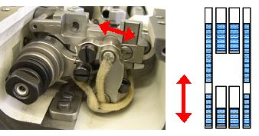
The front – to – back position adjustment prevents the fabric dropping in the slots between main feed dog and diff. feed dog in case of very short stitch length.

3, Presser foot tilt NEW
The presser foot tilt is adjustable.
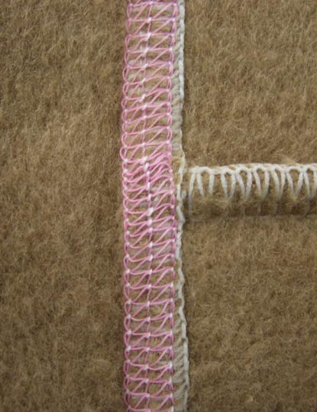
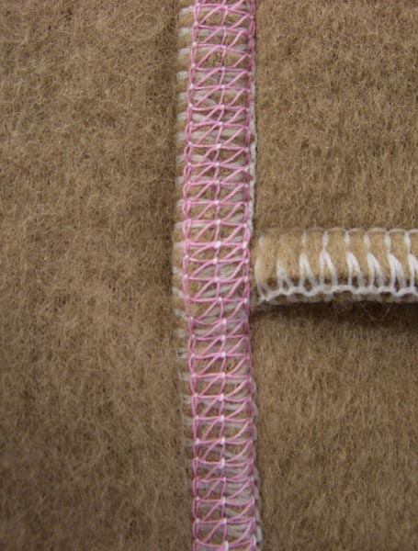
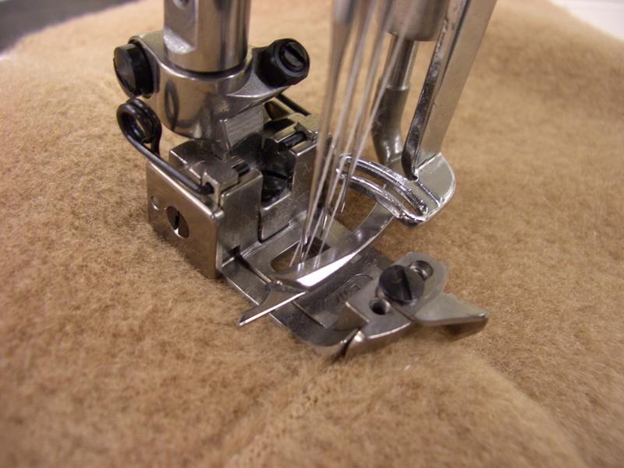
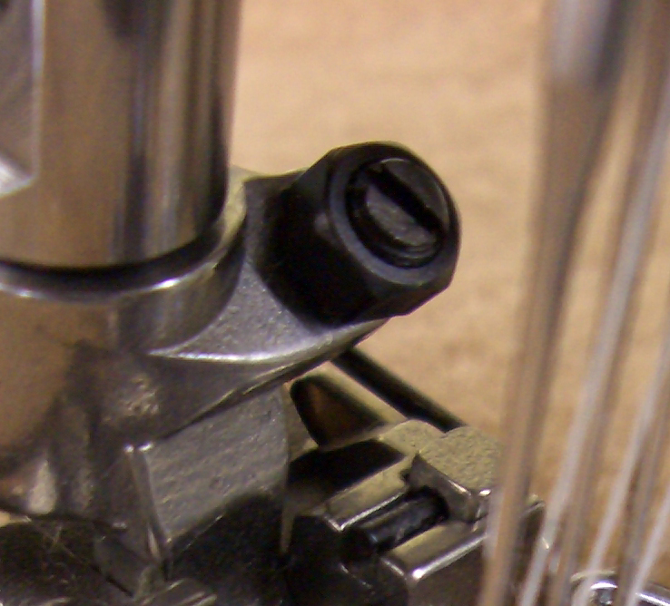
Seam jamming can occur!
If the presser foot is tilted up, the machine will sew over the cross
seam
seam more smoothly.

Equipped with a presser foot on which tilt adjustments can be made easily (W1662-01G).
These machines can sew over cross seam sections more smoothly when sewing heavy weight fabrics.

4, Lubrication and drain mechanism

  - forced drain mechanism for the needle bar area, like W-series
NEW
  - forced drain assembly for the cylinder bed area
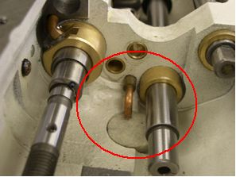

NEW
  - added oil seal for the shaft of the feed dog up-and down movement and for the differential front to rear movement

NEW
  - An oil seal has been added to the internal side of the spreader shaft bushing and the presser foot shaft bushing.

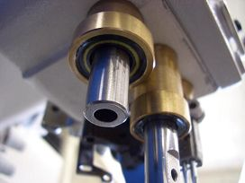

NEW
  - Metallic sheet packing that clings closely to the cylinder cover and the bed cover has been employed.

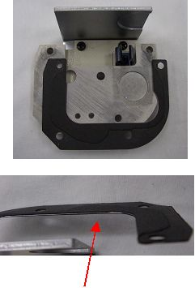

The metallic sheet gasket cannot be damaged if the covers are attached/detached repeatedly.

4, Looper thread take-up

  - Simple to raise by pressing the push button for easy threading (like W-series)
NEW
  - Complete thread guide block is removed just by loosening 2 easy accessible screws.

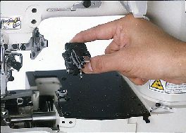

5, Rust-proof measures NEW
are employed for various parts,

- such as the specially coated needle plate
- and the differential feed adjustment lever

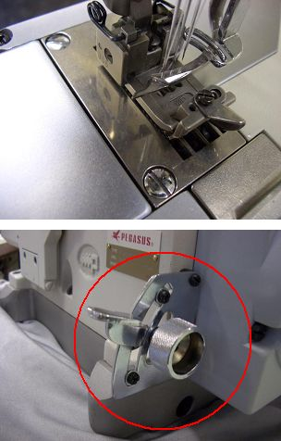

- Various parts have been changed from black oxide to chrome plating
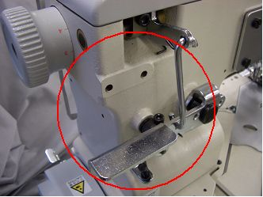

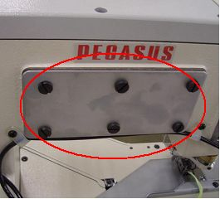

6, Under thread trimmer UT
NEW
- The self-locking nut type screw was introduced newly for adjusting the knife installation angle. This self-locking nut cannot loosen.

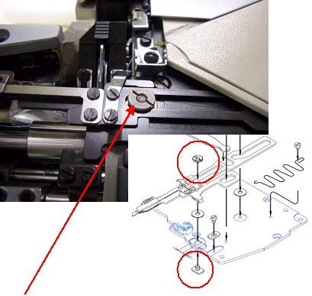
self-locking nut

7, Left hand knife FT0C

W1662 is already available in subclass –35 for hemming, with trimming the edge of the turned down hem, for achieving high quality seams, especially on articles with side seams.

- FT0C ensures that the fabric is always inside the seam (optional 1 -2 mm outside the seam)

- hem width can be performed very accurate all way round with a tolerance of +/- 1 mm
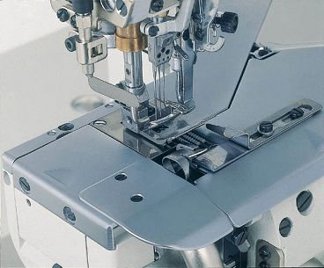

Showing the detachable device FT0C (common with W2600).
Knife up- and down stroke: 3 ~ 6 mm
Trimming left - right position: 1- 5 mm
(from needle drop point
max. speed: 5000 rpm)

Suitable table top for W1662

Basically the table top from W600 – series can be used, with a small modification in the area of the belt cover.

Needle positioner:
In case a synchroniser for needle positioning has to be used, it can be fitted to the pulley. The adoption for the synchroniser is combined with the pulley (like W1562N).

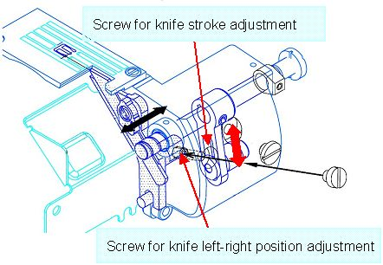
W1662 - Common Specifications

Subclasses: -01（Multi use for -03, -08）
-08 and -35
Max. speed: 6,000 rpm * The maximum speed is different depending on the subclass and the sewing condition
(subcl. –35 with FT0C ~ 5000 rpm)
Circumference of arm: 270 mm
Pressure foot lift: 5.4 mm (-01 / -02) ・ 5.8 mm (-08)
Number of Needles and Needle distance:
2-needle (3.2 mm/ 4 mm/ 4.8 mm *）
3-needle (5.6 mm / 6.4 mm)
Standard needle: UY128GAS
Presser foot: Tilt type pressure foot which sews smoothly over the cross seam is adopted. * Only for -01 type

Feed type: Differential bottom feed
Stitch length: 1,0 ～ 4,4 mm
Differential movement: 0,8 ～ 6,0 independent
driven)
Standard stitch length:11～14 stitches / inch (BS, BT needle plate）
Less than 10 stitches / inch （CT needle plate)
Stitch length adjustment: Push button type
Diff. feed amount adjustment: Intermittent type (without micro adjustment)
Devices : UT / FT / (RP not assigned yet)

Available Subclasses:

-01G = plain seaming
W1662-01Gx248BS/UT3J
W1662-01Gx356BS
W1662-01Gx356BS/UT1L
W1662-01Gx356BS/UT3J
W1662-01Gx356BS/UT3M
W1662-01Gx356BS/UT4M
W1662-01Gx364BS
W1662-01Gx364BS/UT1L
W1662-01Gx364BS/UT3J
W1662-01Gx364BS/UT3M
W1662-01Gx364BS/UT4M
-01G is including guides for covering –03,
guides for hemming -08
and bracket for binder -02
-03F = covering
W1662-03Fx356BS
W1662-03Fx356BS/UT3M
-08 = hemming
W1662-08Ax356BS/UT3J
W1662-08Ax356BT/UT3J
W1662-08Ax364BS/UT3J
-035 = hemming with
under edge trimming (FT0C)
W1662-35Bx356BS/FT0C
W1662-35Bx356BS/FT0C/UT3J
W1662-35Bx356BS/FT0C/UT4M
W1662-35Bx356BT/FT0C
W1662-35Bx356BT/FT0C/UT1E
W1662-35Bx356BT/FT0C/UT3J
W1662-35Bx356BT/FT0C/UT4M
W1662-35Bx364BS/FT0C/UT3J
W1662-35Bx364BS/FT0C/UT4M
W1662-35Bx364BT/FT0C
W1662-35Bx364BS/FT0C/UT3J
W1662-35Bx364BS/FT0C/UT4M
Thread cutter UT
UT1E = solenoid driven UT
(with thread wiper)
UT1L = solenoid driven UT
(without thread wiper)
UT3J = pneumatic driven UT
(with air blower type thread wiper)
UT3M = pneumatic driven UT
(without thread wiper)
UT4M = pneumatic driven under bed
and top cover thread trimmer
(without thread wiper)
Availability depending on subclass.
Please see attached UT-table.

The new gauge parts catalogue of W1662 is available for download in the section PE-News.

You also can download the PE-News as PDF – file and as original Word document for your translation, to make it available for your sales and technical team in your native language.

Ullrich Rabe, PE

 |  |  |  |  | W1600 | UT - device
 |  |  |  |  |  |  |  |  | W1600
 |  |  |  | UNDER THREAD TRRIMER | top cover thread trimmer | NEEDLE THREAD WIPER | PRESSER FOOT LIFTER | 01 | 03 | 08 | 35B
U | T | 1 | E | ELECTRIC TYPE | NO | electric | electric | - | - | ○ | ○
U | T | 1 | L | ELECTRIC TYPE | NO | without | electric | ○ | ○ | - | -
U | T | 3 | J | PNEUMATIC  TYPE | NO | pneumatic | pneumatic | ○ | - | ○ | ○
U | T | 3 | M | PNEUMATIC  TYPE | NO | without | pneumatic | ○ | ○ | - | -
U | T | 4 | M | PNEUMATIC  TYPE | pneumatic | without | pneumatic | ○ | ○ | ○ | ○
 |  |  |  |  |  |  |  | ○ | = assigned
 |  |  |  |  |  |  |  | - | = not available

